Alige Sravan Putra Hno: 6-22
Christian colony
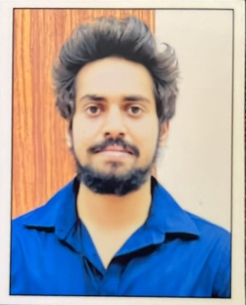
Allipur , Zahirabad , Sangareddy
Pin :502318
Mobile : 8008213778
Aligesravan@gmail.com

CAREER OBJECTIVE
To work In an organization in a responsible position where my technical and management skills should be enhanced and should be implemented for organization's growth.

ACADEMIC QUALIFICATIONS

TECHNICAL SKILLS

- Basic Java
- Basic C programming
- Auto CAD 2d Beginner
- Ms word
- Ms excel

INTERPERSONAL SKILLS
Degree | Educational Institution | Percentage (%)
Bachelor of engineering(B.E), Mechanical engineering | Gokaraju rangaraju institute of engineering and technology | 62
Senior secondary (XII), Science | narayana junior college | 91.4
Secondary (X) | keshavareddy concept school | 93

  - Ability to work in Challenging environment and adverse situations.
  - Decision making and problem solving
  - Good written and spoken communication.
  - Softspoken.
  - Meticulous and quicklearner.

ACHIEVEMENTS

PROJECTS

Project Name -

Mini Project :

DESIGN ANALYSIS AND TOPOLOGY OPTIMIZATION OF STEERING KNUCKLE STRUCTURE

Major Project :

MACHINABILITY CHARACTERISTICS OF SUPER ALLOYS USING COATED INSERTS WITH HIGH SPEED TURNING UNDER DRY CONDITIONS

Skills gained : Finite Element Analysis (FEA)

Topology Optimization

Material Selection and Justification

Sensitivity Analysis

Collaboration and Project Management

Documentation and Reporting
Achievements:
Successfully reduced the weight of the steering knuckle by [percentage], resulting in [specific benefits such as improved fuel efficiency or enhanced vehicle handling].
Ensured the final design met or exceeded all performance and safety standards, contributing to the overall improvement of the vehicle's suspension system
- Industrial visit to coca cola factory
- Volunteer in N.S.S (National Service Scheme)
- Seminar presentation on the topic -working of an ICengine
- Participated in NPTEL course (automation in manufacturing , processing of polymers)

HOBBIES

Listening music , watching movies , and watching anime

LANGUAGES

English , Hindi , Telugu

